Group 5: HealthScope

<https://banban.kanbantool.com/>

We have used ‘Kanban tool’ as the project management tool for this project. So developed a 5 phased project namely Research, Architecture/Design, Infrastructure, Development and Bug control.

1. **Research Phase**

In this phase we read the material from the CDC websites and various papers published by them.

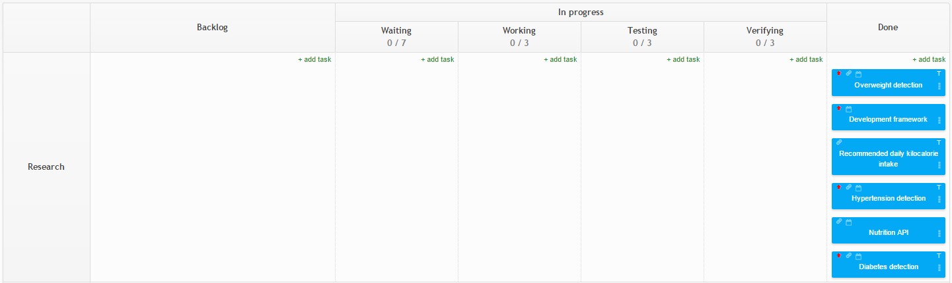

1. **Architecture/Design**

All the modules of the project were decided during this phase. Overall we defined a blue print of the project in this phase.

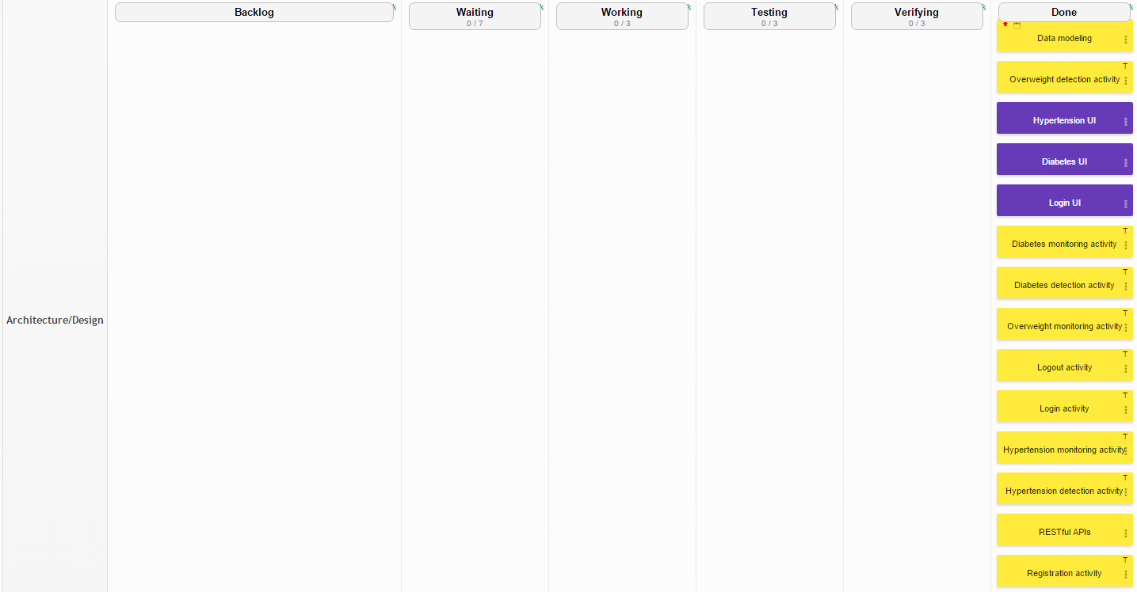

1. **Infrastructure**

In this phase we decided the tools and setup the workspace to work during the development phase.

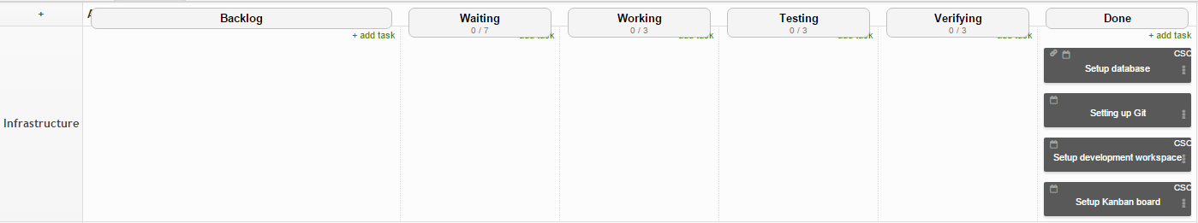

1. **Development**

We developed the application in this phase using Java, Ionic and hosted it on Bluemix.

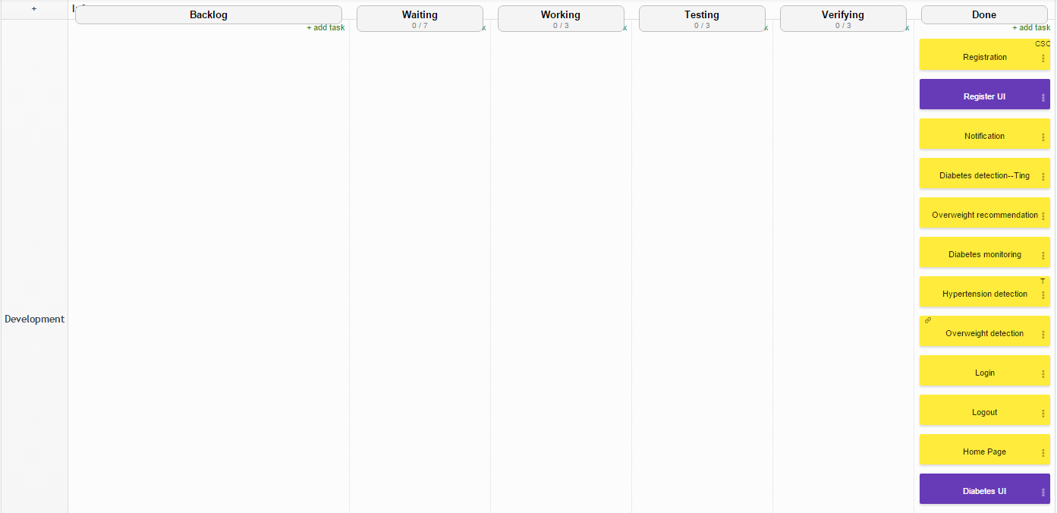

1. **Bug Control**

Quality check for the app was carried out in this phase.

